Strace Debugging Program:

as shown in the following screenshot
The Command used is strace -c ./a.out

The strace command is a powerful diagnostic, debugging, and performance-analysis tool for Linux systems. It traces system calls and signals used by a program during its execution. The -c option provides a summary of system call usage statistics instead of printing the details of each call.
When running strace -c ./a.out, you are tracing the system calls of the ./a.out program while displaying a summarized table of system call statistics at the end.
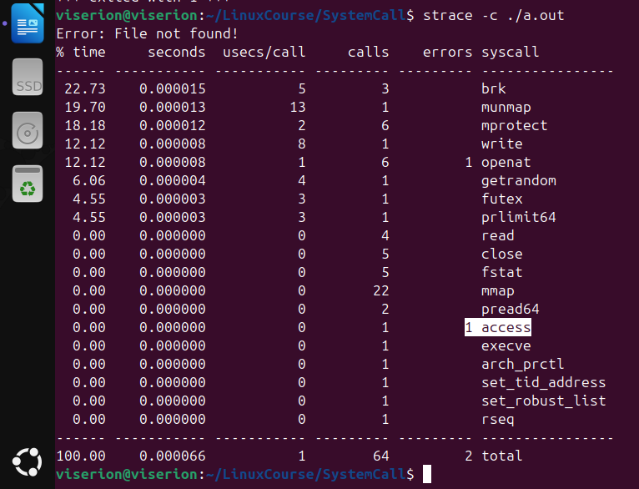

There are 2 errors are found In the previous code:
1-→ openat system call
2-→ access system call

to find out the reason for those errors:
use the command: strace ./a.out 2>&1 | grep openat

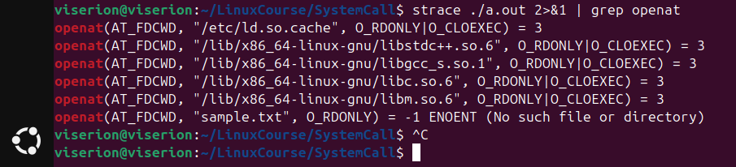

them use the same command with the other system call:
strace ./a.out 2>&1 | grep access

